A MOBILE-BASED PERSONAL HEALTH MONITORING SYSTEM USING CLIENT-SERVER ARCHITECTURE

A Final Year Project Work

Submitted by:

[BELINDA KUMI]
[B203240033]

Department of Computer Science Koforidua Technical University

July 2026
CHAPTER ONE
INTRODUCTION
1.1 BACKGROUND OF STUDY
With today’s technological advancements, mobile phones and wearable devices have become extensions of an increasingly diffused and smart digital infrastructure. In this paper, we examine mobile health (mHealth) platforms and their health and economic impacts on the outcomes of chronic disease patients. To do so, we partnered with a major mHealth firm that provides one of the largest mobile health app platforms in Asia specializing in diabetes care. We designed and implemented a randomized field experiment based on detailed patient health activities (e.g., steps, exercises, sleep, food intake) and blood glucose values from 1,070 diabetes patients over several months. Our main findings show that the adoption of the mHealth app leads to an improvement in health behaviours, which in turn leads to both short-term metrics (such as reduction in patients’ blood glucose and glycated hemoglobin levels) and longer-term metrics (such as hospital visits and medical expenses). (Ghose et al, 2022)
Health is characterized as a full state of physical, mental, and social well-being and not merely a lack of illness. Health is a fundamental element of people’s need for a better life. Unfortunately, the global health problem has created a dilemma because of certain factors, such as poor health services, the presence of large gaps between rural and urban areas, physicians, and nurses’ unavailability during the hardest time. (Rahaman et al, 2020)
A large part of these cost reductions stem from changing the healthcare model from a reactive to a proactive approach, focusing on health management rather than disease treatment. This is expected to result in fewer hospitalizations, less doctor visits, and less treatments. Precision medicine provides the possibility of tailoring healthcare interventions to individuals or groups of patients based on their disease profile, diagnostic or prognostic information, or their treatment response. The tailor-made treatment opportunity will take into consideration the genomic variations as well as contributing factors of medical treatment such as age, gender, geography, race, family history, immune profile, metabolic profile, microbiome, and environment vulnerability. (Bohr et al, 2020)
Healthcare systems are essential for improving and maintaining the health among population groups. They result from the combined efforts of government agencies, institutions and resources, with the aim of improving health of their people. Properly designed health systems should have a strong component of health promotion and disease prevention, provide for early disease detection and health communication and facilitate appropriate intervention. A health system requires staff, funds, information, supplies, transport, communication networks, and overall guidance and direction (Petersen et al, 2020)
In Ghana and across sub-Saharan Africa more broadly, access to regular clinical health monitoring remains unevenly distributed. Urban health facilities are often overstretched, and rural populations frequently lack proximity to diagnostic services (WHO, 2021). Mobile phone penetration, by contrast, has grown significantly across the continent, with smartphones increasingly accessible even in lower-income demographics (GSMA, 2023). This gap presents a practical opportunity, since a mobile-based health monitoring system can extend the reach of health awareness tools to populations that are currently underserved by formal healthcare infrastructure.
1.2 PROBLEM STATEMENT
Despite the widespread availability of smartphones and increasing access to low-cost health wearables, there is currently no lightweight, accessible, and integrated mobile platform that enables individuals in resource-constrained environments to collect personal health data, transmit it for processing, and receive meaningful health reports in return. The typical individual seeking to monitor their own health outside a clinical setting faces a fragmented landscape: wearable devices may collect raw data but provide little interpretive context; standalone health applications may display readings without any server-side analysis; and the gap between data collection and actionable health insight remains largely unaddressed for non-clinical users. A smartphone alone cannot directly measure physiological signals such as body temperature, blood oxygen saturation, or heart rate without peripheral hardware, yet most existing mobile health applications are designed either for users who already own specific wearables or for direct sensor input that the majority of general users do not have access to. This means that users who rely on manually entered health data readings taken from basic thermometers, blood pressure cuffs, or pulse oximeters have no reliable platform that accepts this input, processes it meaningfully on a server, and returns a structured health report. Furthermore, the processing of health data requires computational logic that is too resource-intensive and sensitive to be handled entirely on a mobile device, yet building a system that correctly separates these responsibilities across a client-server architecture, with a Python backend capable of health logic processing and a React Native frontend capable of cross platform delivery, has not been attempted for this specific use case and target context. The result is that individuals who are health-conscious but not technically sophisticated, or who lack access to premium health monitoring ecosystems, are left without a practical tool for ongoing personal health awareness.
1.3 GENERAL OBJECTIVE
To provide a client-server based mobile personal health monitoring system that uses mobile devices and centralized server connectivity to effectively monitor, store and manage users’ health information.
1.3.1 SPECIFIC OBJECTIVES
- To develop a smartphone application that records and tracks personal health information, including blood pressure, temperature, heart rate, and blood oxygen saturation.
- To implement a client-server architecture that enables safe data exchange between the central server and the mobile application.
- To implement a relational database for storing user records, historical data, and reports efficiently.
- To provide a centralized database for the safe management, retrieval, and storage of users’ medical records.

1.4 RELEVANCE / SIGNIFICANCE OF STUDY
For individual users, the most direct benefit of this system is access to a personal health awareness tool that does not require a clinical visit or expensive specialist hardware. A person who owns a basic thermometer or a low-cost pulse oximeter can now enter their readings into a mobile application and receive a processed health report that interprets those readings against standard reference values. This turns an isolated reading into information the user can act on, and helps them judge when a visit to a health facility is warranted. In environments where healthcare access is geographically or financially constrained, this kind of early awareness can prompt a person to seek care before a condition worsens.
For the broader healthcare ecosystem, particularly in developing contexts such as Ghana, the system contributes to reducing the burden on formal health facilities by equipping individuals with tools for self-monitoring. When people can track their own health trends over time, they arrive at clinical consultations better informed and with documented history, which improves the quality of the interaction and potentially reduces the number of visits required for routine monitoring. The system is not a replacement for professional diagnosis, but it can make the consultation itself more productive.
From a technical and academic standpoint, this project demonstrates a practical implementation of client-server architecture applied to the mHealth domain using current, open-source technologies.
The combination of a Python backend and a React Native frontend represents a stack that is widely used in industry and straightforward for others to extend. The project contributes a working reference model for similar systems targeting resource-constrained deployments, where licensing costs and infrastructure dependencies must be minimized.
For the Department of Computer Science at Koforidua Technical University, the project adds to a body of work that connects software engineering practice to real community needs. It shows that final year students can design, build, and document systems that have real use outside the classroom, which benefits both the institution and the employability of its graduates.

1.5 SCOPE OF STUDY
This project covers the design, development, and testing of a functional client-server health monitoring system consisting of two primary components: a mobile application built in React Native, and a backend server built in Python using the Django framework and the Django REST Framework. The system is scoped for individual personal health monitoring and is not intended for clinical deployment or integration with hospital information systems.
On the client side, the application targets Android and iOS platforms through React Native's cross platform build system. The health signals supported include body temperature, heart rate, blood oxygen saturation, and blood pressure. All health readings are entered manually by the user, using values taken from ordinary measuring instruments such as a thermometer, a blood pressure cuff, or a pulse oximeter. The application handles user authentication, data submission, and the display of health reports returned by the server.
The server component is responsible for receiving health data submissions, validating inputs, processing readings against standard clinical reference ranges, generating structured health reports, and persisting records to a relational database. The server is scoped for local and cloud-hosted deployment and communicates with clients via a RESTful HTTP API. Real-time streaming, automatic capture of readings from external sensor hardware, integration with electronic health records, and clinical-grade diagnostic logic are outside the scope of this project.
Testing covers functional verification on both target mobile platforms, API endpoint testing, database integrity checks, and basic performance testing with simulated concurrent users. Security hardening beyond standard input validation and token-based authentication, formal clinical validation of the health logic, and compliance auditing against healthcare data regulations are noted as directions for future work and are not part of this project's deliverables.

1.6 LIMITATIONS OF STUDY
Absence of end-to-end encryption in the initial implementation. Transmitting health data between the mobile client and the server without TLS encryption exposes the communication channel to potential interception on unsecured networks. This is a known gap in the current implementation. The decision to defer full TLS implementation is a consequence of the project timeline and the need to prioritize core functional features first. Encrypting the channel correctly, with proper certificate handling and key management, is the most important security addition for any subsequent version and is documented explicitly as such.
Reliance on user-entered data introduces accuracy limitations. Because the application does not read from measuring instruments directly, every health reading is entered by hand. Manual entry is inherently susceptible to transcription errors, misremembered values, and inconsistent measurement conditions. The system cannot verify the accuracy of user-submitted readings and will process and report on whatever data is provided. This means the health reports generated are only as reliable as the inputs they are based on, which is a fundamental constraint for a system of this design.
The health report generation logic is not clinically validated. The processing module on the server evaluates readings against standard published reference ranges for temperature, heart rate, blood pressure, and blood oxygen saturation. While these ranges are drawn from established medical literature, the logic has not been reviewed or certified by a licensed medical professional. The system is explicitly positioned as a personal awareness tool and not a diagnostic instrument. Users are expected to seek professional consultation for any health concerns surfaced by the system.
Testing is conducted in a simulated environment rather than a live deployment.
Performance and reliability findings are based on controlled test scenarios with simulated concurrent users rather than a production rollout with real users across varied network conditions. Certain edge cases such as intermittent connectivity, low-end device behaviour, and unusual input patterns may not be fully captured during the testing phase. Results should be interpreted as indicative of system behaviour under controlled conditions, not as guarantees of performance across all real-world deployment scenarios.
The system has no direct link to the instruments that produce the readings. Because a value is copied by hand from a thermometer, cuff, or oximeter into the application, the system cannot confirm when the measurement was taken or which device produced it. Any capability that depends on verified device data, such as continuous background monitoring or automatic trend capture, is therefore not supported by this implementation.
1.7 ORGANIZATION OF STUDY
This thesis is organized into eight chapters, each addressing a specific aspect of the research and system development process. Chapter One presents the general introduction to the study, including the background to the study, problem statement, objectives, scope, significance, methodology, expected results, organization of the study, and the study work plan.
Chapter Two reviews relevant literature by examining theories, concepts, previous studies, and existing computer-based systems related to the research topic. It also identifies gaps in existing knowledge that justify the development of the proposed system.
Chapter Three focuses on the crystallization of the problem by presenting the background of the case study organization, describing the operation of the existing system, analyzing its strengths and weaknesses, and providing appropriate system models such as context diagrams and data flow diagrams. It also compares the existing system with findings from the reviewed literature.
Chapter Four presents the analysis of the proposed system by outlining its functional and non-functional requirements, major features and components, expected benefits, and the proposed system context diagram.
Chapter Five discusses the detailed design of the proposed system, including process models, algorithms, flowcharts, UML diagrams, data models, database design, entity relationship diagrams, user interface designs, and other relevant design specifications.
Chapter Six describes the implementation of the proposed system, the technologies and methods used in its development, and the testing procedures employed to verify the functionality and performance of the system.
Chapter Seven provides the system documentation, including hardware and software requirements, installation procedures, user guide, and screenshots demonstrating the use of the various system components.
Finally, Chapter Eight presents the conclusion of the study by summarizing the research findings, offering recommendations based on the outcomes of the study, and suggesting areas for future research and system enhancements.

1.8 PROJECT SCHEDULE
A Gantt chart will be used as the project management tool to effectively plan, schedule, and monitor the development of the package tracking system with proof of delivery and chatbot integration. It provides a clear timeline of the project's activities, indicating the duration of each task, their respective deadlines, and the individuals responsible for their execution. The project schedule is presented in the table below.
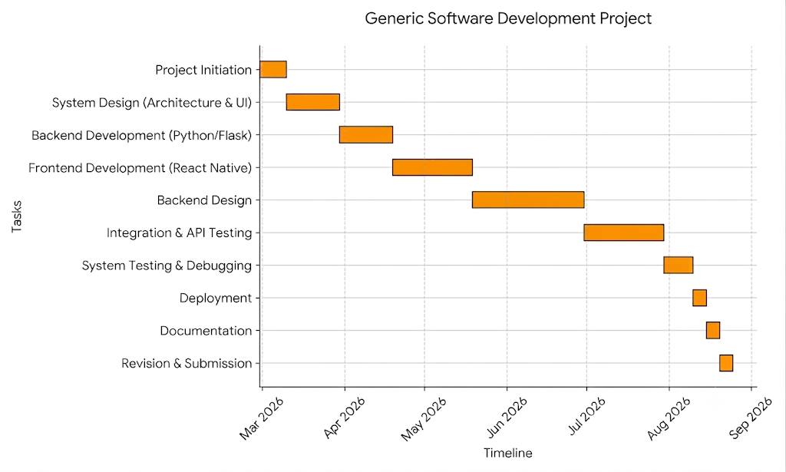

1.9 CONCLUSION
This chapter has established the foundational framework for the development of a client-server based mobile personal health monitoring system. By examining the current healthcare challenges in developing contexts such as Ghana, where professional diagnostic services remain unevenly distributed despite rising smartphone penetration, the study identified a clear opportunity for a mobile health (mHealth) intervention. To bridge this gap, specific objectives were defined to guide the design, database architecture, client-server implementation, and functional testing of the system. The study also acknowledges the practical limitations of the work. Having established the introductory context, objectives, and systemic boundaries of this project, the next chapter will present a comprehensive review of relevant literature to provide the theoretical, conceptual, and the system’s design. This upcoming chapter will critically explore underlying theories and concepts related to the research topic, alongside previous studies and existing computer-based systems in the mHealth domain.

CHAPTER TWO
LITERATURE REVIEW
2.0 INTRODUCTION
In recent years, the intersection of mobile technology and healthcare has catalysed a significant paradigm shift in patient care, moving from reactive, hospital-centric models to proactive, patient-cantered approaches. However, as medical needs have grown more complex, the academic and engineering focus has shifted toward robust, real-time tracking systems capable of continuously monitoring vital signs such as heart rate, blood pressure, and glucose levels to assist in clinical decision-making. This chapter presents a review of relevant literature related to the study. The purpose of the literature review is to examine existing theories, concepts, models, technologies, and previous research findings that are relevant to the proposed system. It provides a comprehensive understanding of the current state of knowledge in the field and identifies gaps that justify the need for the research.
Health facilities are not accessible or affordable to all, despite having excellent infrastructure and cutting-edge technology. Smart healthcare (SHC) aims to assist users by informing them about their medical conditions and keeping them informed about their health. SHC allows people to handle specific emergencies on their own. SHC employs modern information technology, e.g., IoT, big data, cloud computing, and artificial intelligence (AI), to completely change the current healthcare system into a more efficient and convenient one. SHC promotes interaction among all stakeholders in the medical industry. It ensures that users receive the services they require, assisting parties in making informed decisions and facilitating resource distribution. SHC technology improves disease diagnosis, patient treatment, and overall quality of life. (Khan et al. 2021).
Healthcare sector started leveraging information technology in the recent years to develop modern applications and enhance the diagnostic and treatment processes. Advanced techniques and scientific theory are the major entities that generate huge volumes of digital data. Followed by advanced clinical applications are the brainchildren of information technology which have been developed in the recent times. The associate editor coordinating the review of this manuscript and approving it for publication was Abdulsalam Yassine. Also, advanced healthcare is assumed to have simple, elegant, and multi-tasking applications. These modifications are incorporated as clinical model extension (from disease-based to patient-based care), informatization development changes (from medical data to regional medical data), extension in clinical management (general management to personal management), and modifications from prevention and treatment (Shifting of concentration from disease treatment to preventive medical system (Mansour et al. 2021)
2.1 REVIEW OF RELATED LITERATURE
Human life more comfortable and simpler. It has influenced the various aspects of everyday life and medical field is not an exception. Instruments based on latest technology having capability to analysis internal diseases are in great demand these days. Patients prefer their own devices to monitor important parameters and help specialist to have immediate access in emergency e.g. Apple watches. Such devices are costly and only few can afford it. Advancement in mobile technology and smart devices has created incredible impact in Biomedical engineering. Medical engineers are progressively taking the advantage of producing better devices with latest technology. In the past, it was difficult to monitor patients continuously in remote area during critical conditions. But advancement in technology enables monitoring of a patient continuously and sends data to the server. Using this approach doctors can access data and inform caretaker when some critical condition arises. (Sharma et al. 2021).

2.2 REVIEW OF EXISTING SYSTEMS
2.2.1Health Monitor: Sugar & BP
https://play.google.com/store/apps/details?id=com.gthreload.health.monitor.gp&pcampaignid=web_share
Health Monitor: Sugar & BP is a mobile health-diary application designed to aggregate critical physiological metrics such as blood pressure, blood glucose, heart rate, and blood oxygen levels into a single digital dashboard. The application also features built-in heart rate detection using the smartphone camera sensor.

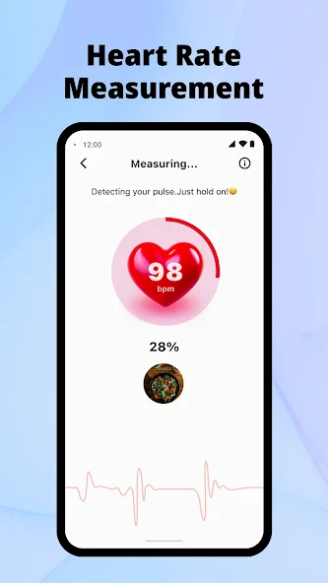

Fig 2.2.2 Home Page for Health Monitor.

2.2.3 OVERVIEW OF THE SYSTEM
The Health Monitor: Sugar & BP application is a mobile-based personal health information system (PHIS) designed to aggregate, track, and visualize critical chronic health biomarkers. Positioned primarily as a digital health diary, the system enables users to consolidate separate medical streams such as hypertension and diabetes management into a single mobile interface. The platform functions through a dual-mechanism model: it utilizes on-device hardware sensors for immediate, localized biological scanning while acting as a centralized relational database for manual medical records.

2.2.4 CONTEXT DIAGRAM
The diagram clearly defines the boundaries of the system. It shows that the application serves two primary masters: the User who relies on it for personal health tracking, and the Admin who ensures the system runs smoothly and handles backend management.

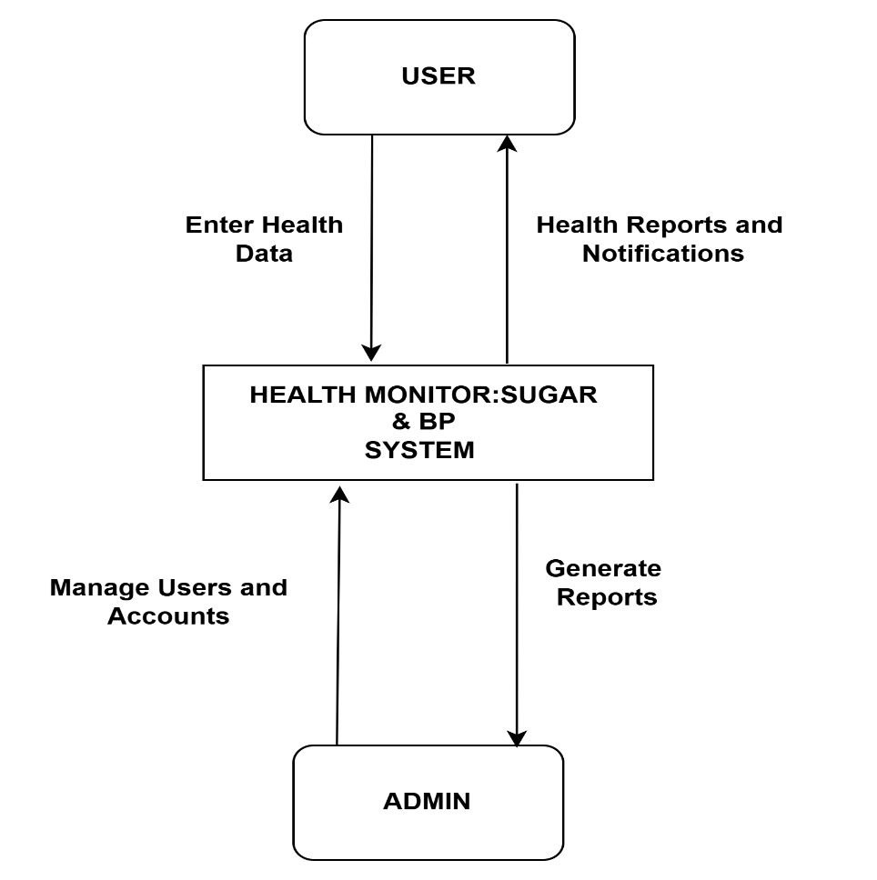

Fig. 2.2.5 A context diagram on Health Monitor

2.2.6 USE CASA FOR THE SYSTEM
The Health Monitor System allows users to input blood pressure and glucose metrics manually or capture them using a phone camera. Users can view personal health trends, receive notifications, and export reports directly to their doctors. Meanwhile, administrators maintain the platform by managing user accounts, pushing system updates, and generating backend reports. All of these interactions from both roles sync directly with a centralized system database to keep information current.

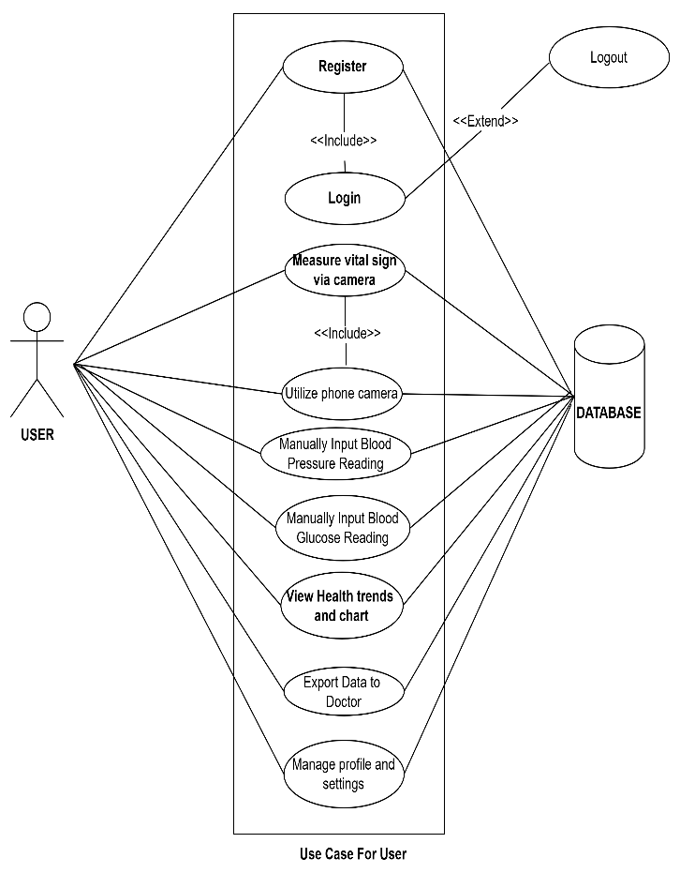
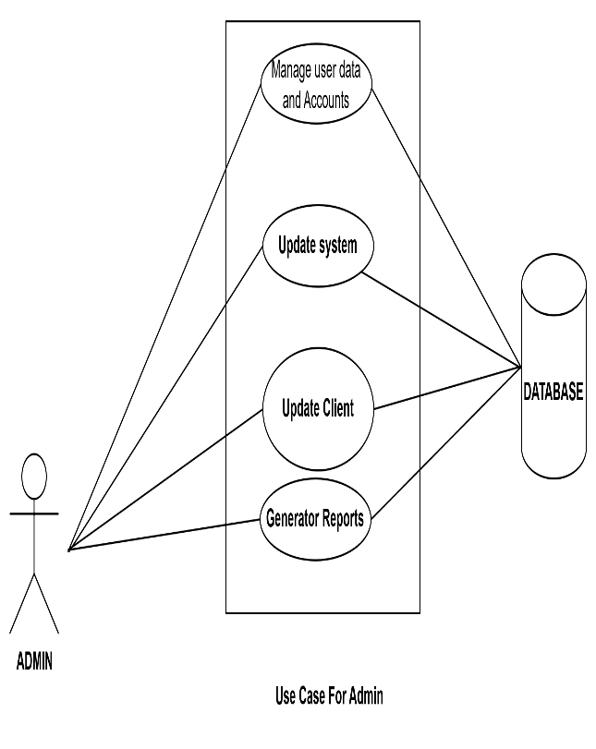
Fig.2.2.8 Use case Diagram for Admin
Fig.2.2.7 Use case Diagram for user

2.2.9 ACTIVITY DIAGRAM
The process begins when a user enters their blood pressure and blood sugar readings, which the system processes and immediately saves to the database. The system then analyzes the metrics to determine if they are normal, branching to either generate a standard report or trigger an alert. Finally, the resulting health report is saved to the database and sent back to the user for viewing.

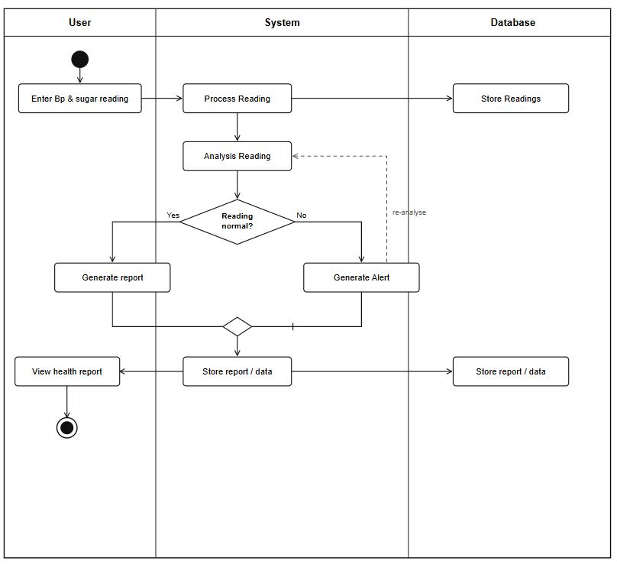

Fig.2.3.0 Activity Diagram

2.3.1 DATAFLOW DIAGRAM
The diagram shows a Blood Pressure and Blood Sugar Monitoring System where the user records their health readings through the system. The BP & Sugar Reading module processes and evaluates the data. If abnormal readings are detected, the system automatically sends an alert notification to the user or caregiver, enabling timely medical attention and supporting effective health monitoring.

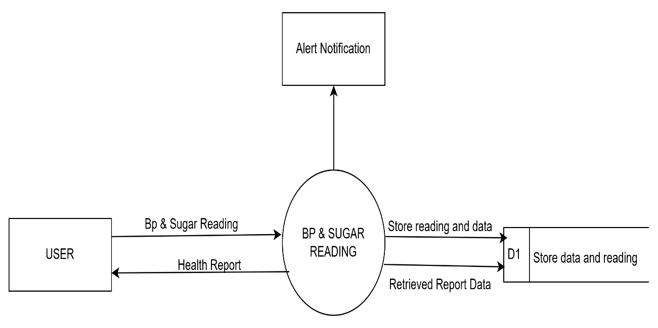

Fig.2.3.2 Dataflow Diagram.

2.3.3 CLASS DIAGRAM
The class diagram shows the main components of the Health Monitoring System and how they interact. The User enters health readings, which are processed and analysed by the Health Monitoring System. The system stores the data, generates a Report, and creates an Alert if abnormal readings are detected. The alert is then sent to the user, enabling timely awareness and appropriate action while supporting effective health monitoring.
.

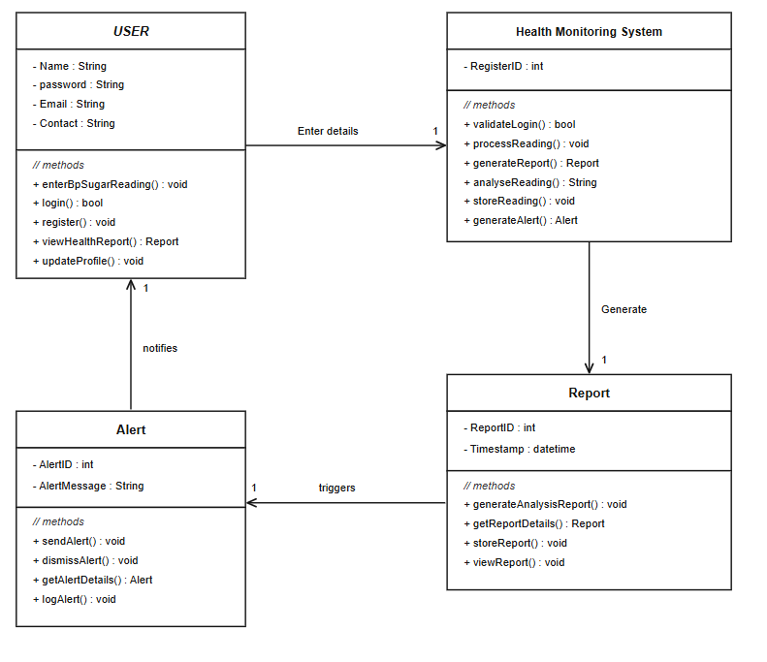
Fig.2.3.4 Class Diagram.

2.3.5 ENTITY RELATONSHIP DIAGRAM
This entity-relationship (er) diagram depicts a database schema for a health monitoring system consisting of four key entities: user, account, admin, and health monitor system. a user (containing details like email, password, contact, and name) creates exactly one account in a 1-to-1 relationship. this central account entity acts as a bridge, allowing multiple accounts (n) to enter details into a single (1) health monitor system, which itself processes readings and generates reports based on a unique registerID. overseeing the system is the admin (identified by adminlD, username, and email), who can generate reports for multiple (n) accounts and perform updates on multiple (n) health monitor systems, establishing 1-to-n relationships across both pathways.
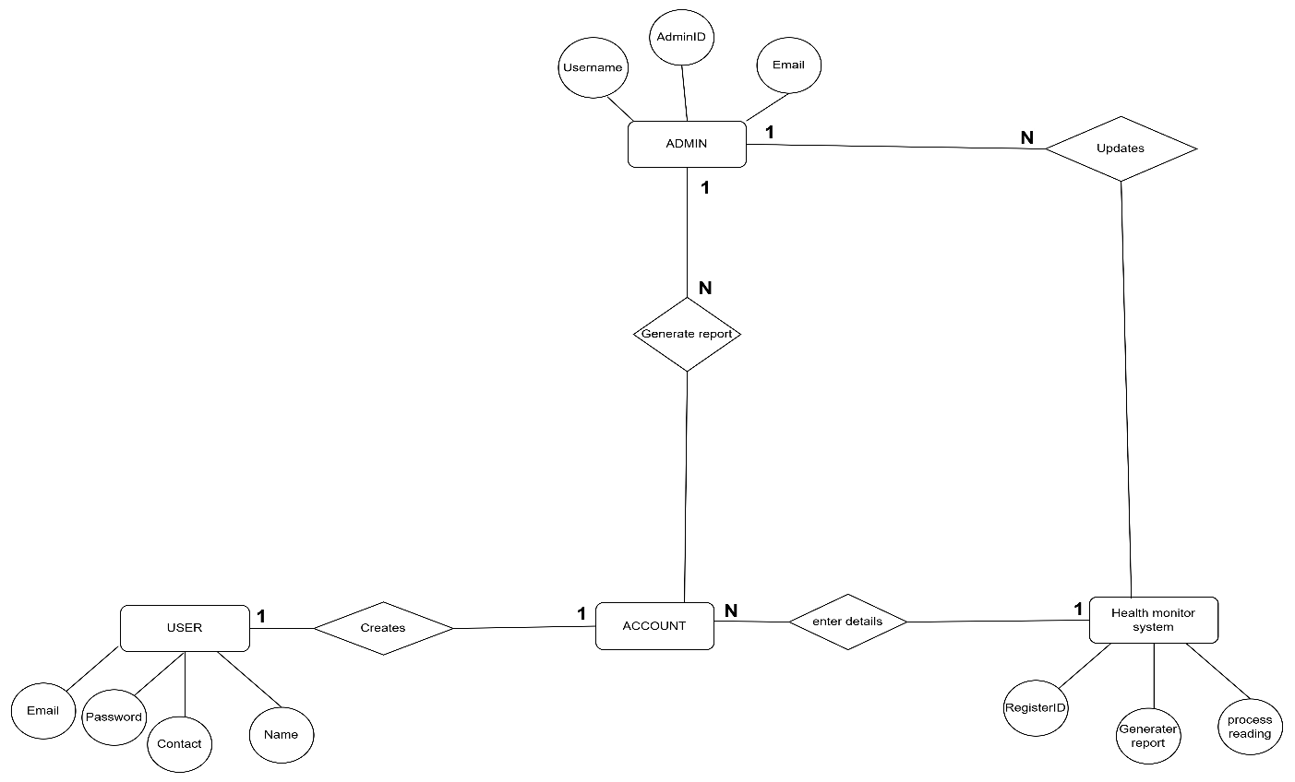

s

Fig.2.3.6 Entity Relation Diagram.

2.3.7 HEALTH WATCH
https://play.google.com/store/apps/details?id=pk.com.toptierventures.healthwatch&pcampaignid=web_shar e
Health Watch is a mobile healthcare application that digitizes patient records and hospital services. It allows hospitals to manage medical information electronically while enabling patients to access and monitor their health records through smartphones. The system improves communication, record management, and healthcare accessibility.

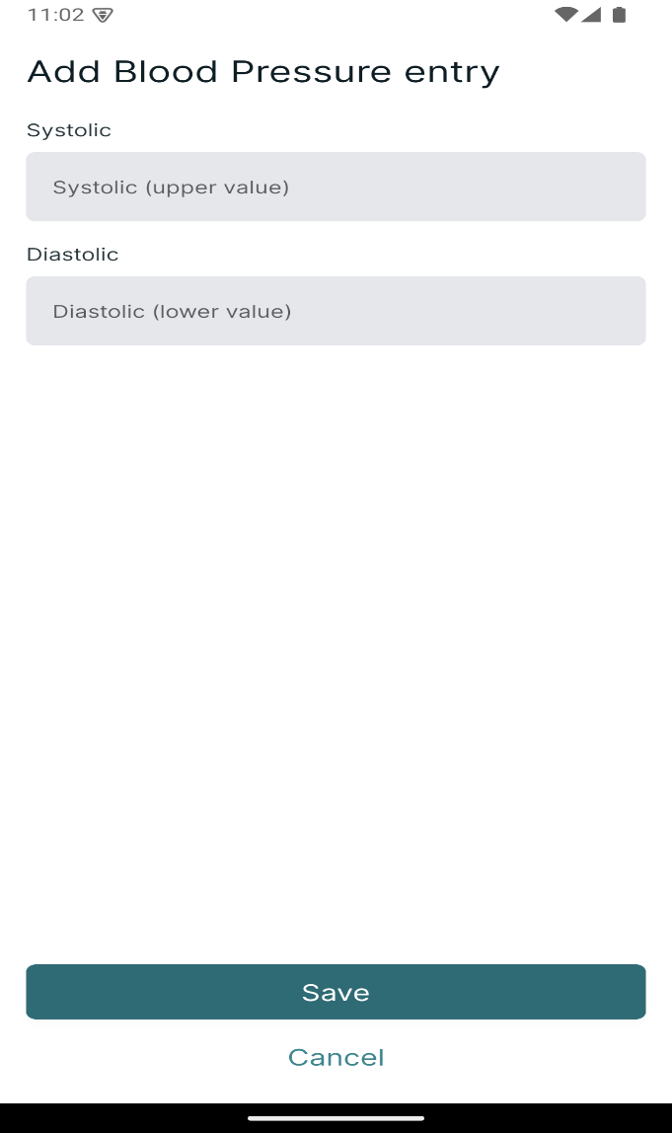

Fig 2.3.8 Home page

2.3.9 OVERVIEW OF THE SYSTEM
Healthwatch is a mobile healthcare application developed to digitize hospital services by allowing hospitals to manage patient records electronically while enabling patients to monitor their medical information through their smartphones. The application serves as a bridge between hospitals and patients by providing secure access to patient medical records, laboratory results, imaging reports, medications, allergies, and visit history.

2.4.0 CONTEXT DIAGRAM
This context diagram represents the data flow for a Health Watch System by mapping how information moves between the central system and three external entities: the User, the Admin, and the Database. The User interacts with the system by submitting profile updates and report feedback, receiving their medical history in return. Meanwhile, the Admin manages background operations by inputting user registrations and record updates, which allows them to pull data regarding visit history, reports, and records from the system. Finally, the system communicates with the Database by sending data to store medical records and pulling data to retrieve those records whenever a user or admin requests information.

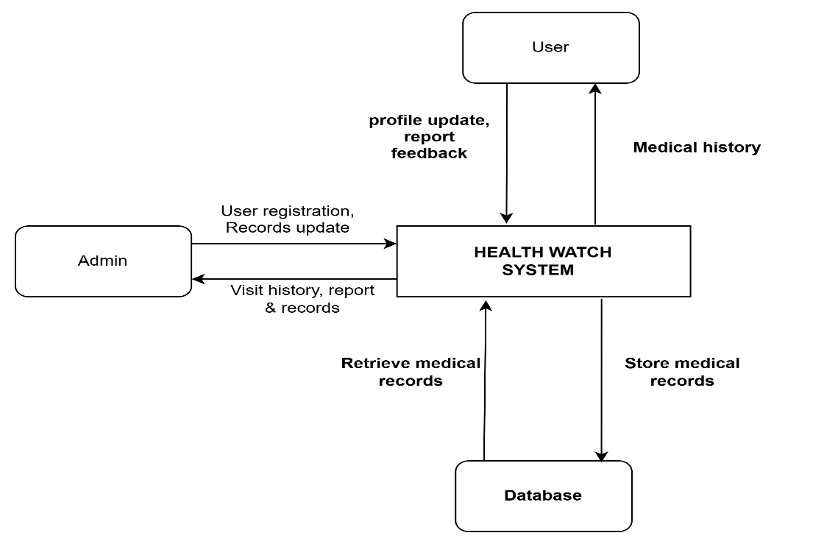

Fig.2.4.1 Context Diagram for Health Watch

2.4.2 USE CASE DIAGRAM
These use case diagrams illustrate the interactions between different actors and the system database, divided into administrative and user-level functionalities. In the Admin diagram, the admin actor triggers four main processes: registering patients, managing patient records, updating medical records, and generating reports, all of which directly read from or write to the central database. In the User diagram, the User actor can register which automatically includes a login step as well as request medical records, view medication details, view medical history, update their profile, and give feedback, with each of these actions interacting with the database. Additionally, logging in features an extended capability allowing the user to log out of the system
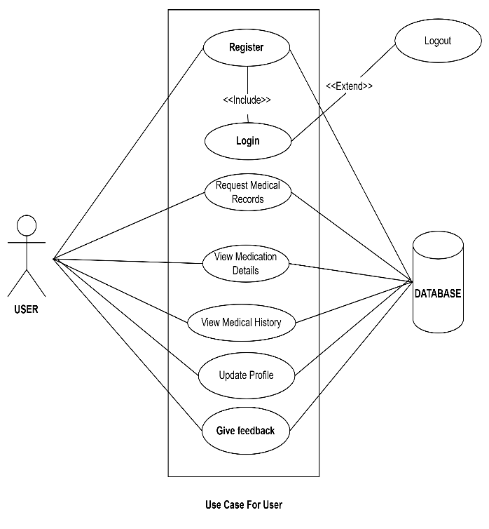
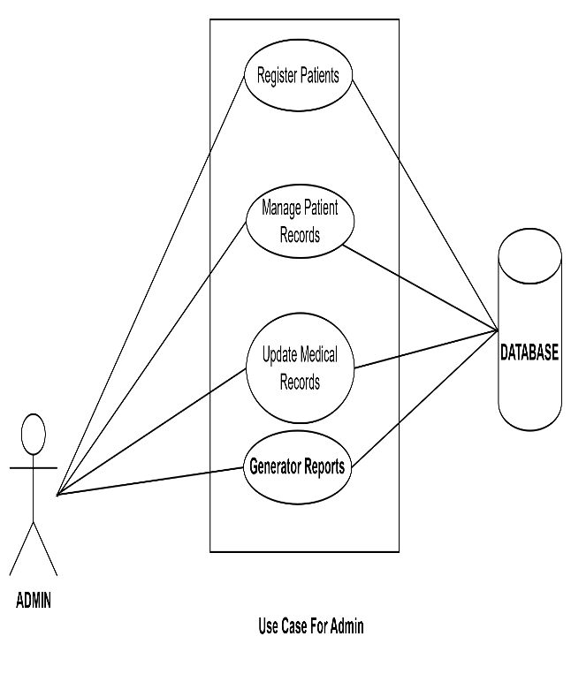

Fig.2.4.4 Use case for user
Fig.2.4.3 Use case Diagram for Admin

2.4.5 ACTIVITY DIAGRAM
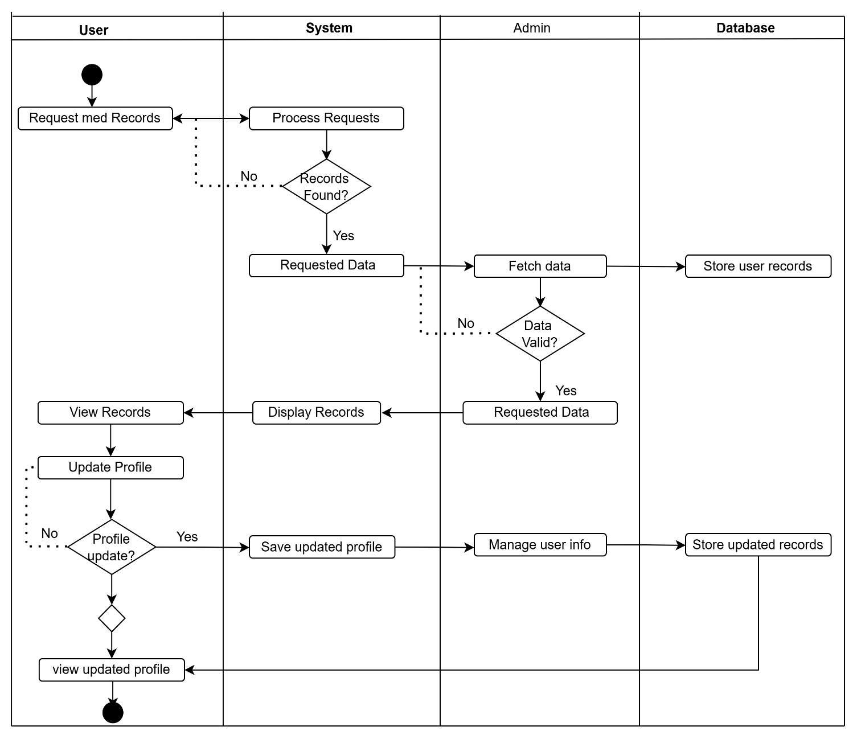
This activity diagram outlines the operational workflow of a medical records system across four distinct lanes: User, System, Admin, and Database. The process begins when a User requests their medical records, prompting the System to process the request and check if the records exist; if they are not found, the system routes the flow back to the initial request. If records are found, the system passes the requested data to the admin, who fetches and validates the information while simultaneously storing user records in the Database. Once the Admin verifies the data is valid, it is passed back through the System to be displayed, allowing the User to view their records. Finally, the User chooses whether to update their profile; if they decline, they proceed straight to viewing the updated profile, but if they accept, the update flows from the User to the System to save it, then to the admin to manage it, and ultimately to the Database to store the updated records before ending the process.

Fig.2.4.6 Activity Diagram

2.4.7 DATAFLOW DIAGRAM
This data flow diagram (dfd) maps out the flow of information between users, administrators, and the central database through the core "health watch process." a user initiates interactions by sending requests to retrieve files ("request records") or modify personal details ("update profile") to the central process, which then delivers "display records" back to the user. The central health watch process services these actions by reading from and writing to the d1 store patient records database to keep patient files current. Meanwhile, an admin oversees the system's administration by receiving forwarded data requests and saved profile files from the central process while returning administrative commands through the "manage user info" data stream.
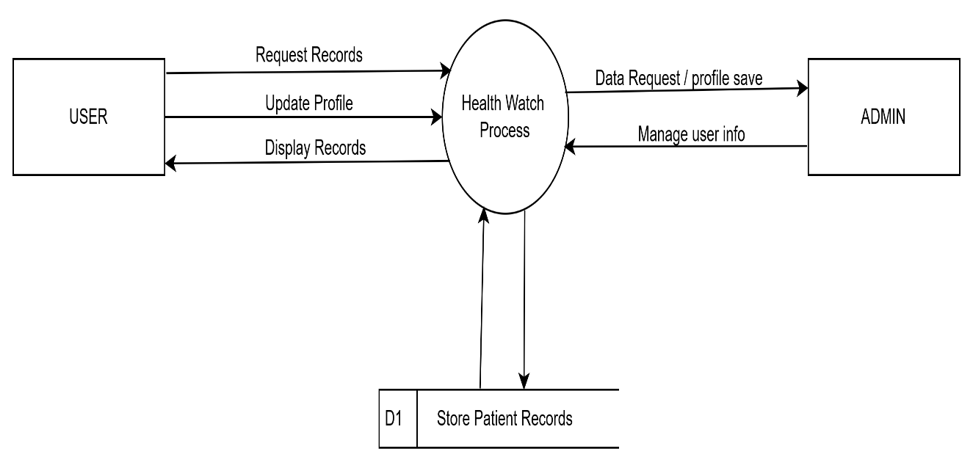

Fig.2.4.82Dataflow Diagram

3.4.9 CLASS DIAGRAM
This class diagram outline a Medical Record Request System involve four key entities. A user initiates the workflow by submitting a record request to view files or update their profile. Each request track status and dates, serving to retrieve the request Medical Record data (such as patients Ids and record type). Finally, an Admin oversees the system by directly managing the medical records database and approving incoming request.
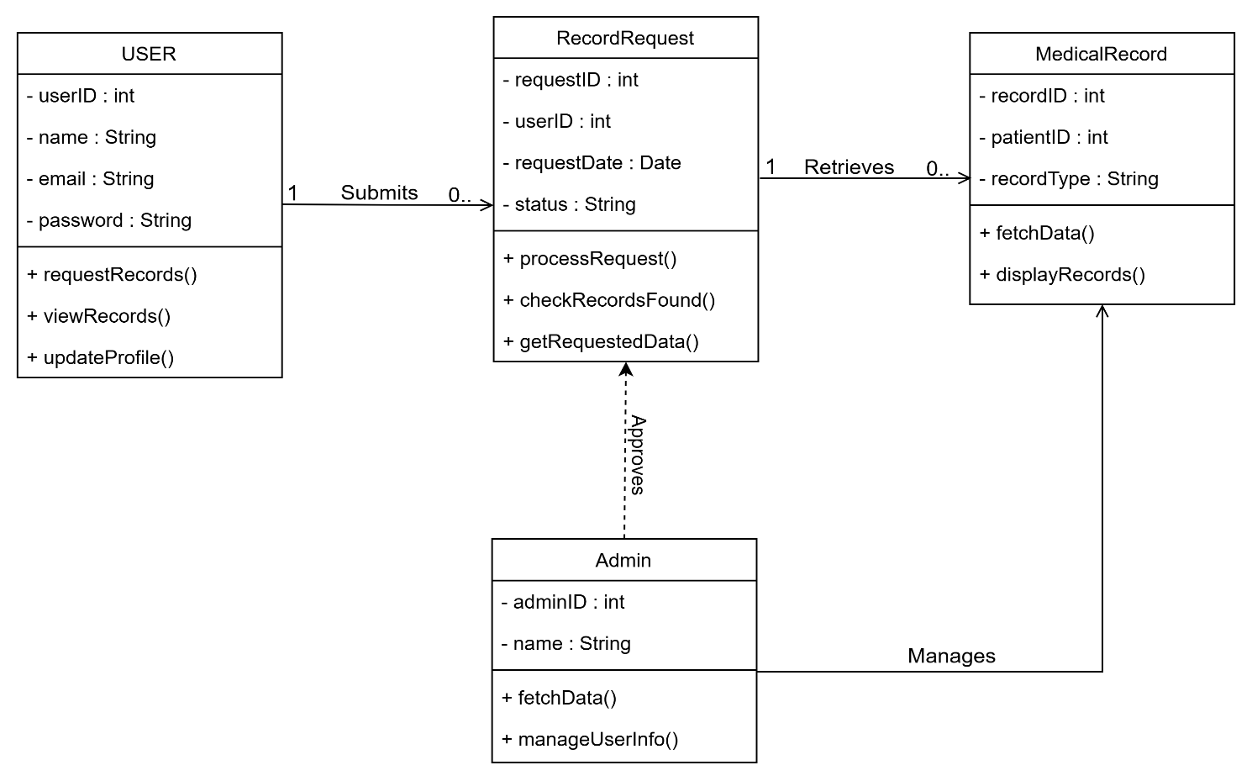

Fig. 2.5.0 Class diagram

2.5.1 ENTITY RELATIONSHIP DIAGRAM

2.5.3 CONCLUSION
This chapter provided a comprehensive review of the foundational theories, conceptual models, and technological advancements shaping the modern mobile health (mHealth) landscape. The literature highlights how smart healthcare (SHC) like Health Monitor: Sugar & BP and Health Watch leverage contemporary information technology to transition clinical models from reactive, disease-based management to proactive, patient-centric, and preventive systems. This lays the groundwork for the following chapter, which is devoted to the crystallization of the problem.

CHARPTER THREE
CRYTALLIZATION OF THE PROBLEM

3.1 INTRODUCTION
The Body Temperature App is a mobile health (mHealth) system designed to help users monitor and manage their body temperature and other wellness information digitally. It allows users to record temperature readings, track health trends, monitor heart rate and breathing rate, manage family health profiles, and generate reports for sharing with healthcare professionals.
The system uses a client-server architecture, where the mobile application collects and displays health data while backend services store and manage user information. By providing digital health tracking and analysis, the app supports early health awareness and convenient monitoring. However, it is a wellness tool and does not replace medical devices or professional diagnosis

3.2 Body Temperature App https://www.bodytemperature.app
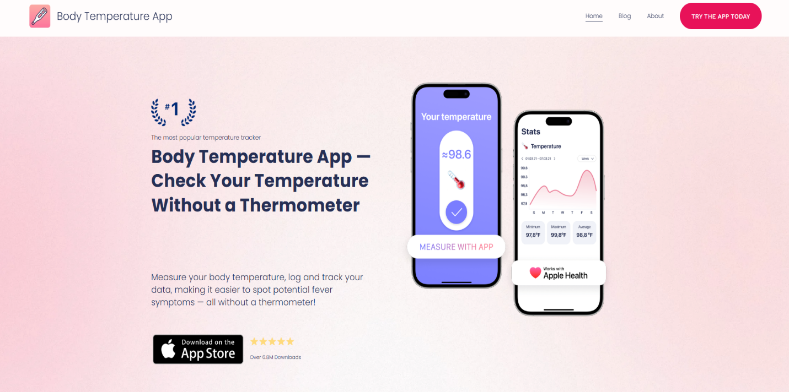

Fig.3.3 Home page
3.4 OVERVIEW OF THE SYSTEM
The Body Temperature App is a mobile health monitoring system that helps users record, track, and manage body temperature and other wellness information. It uses a mobile application, server, and database to collect, process, and store health data. The system provides features such as temperature history, health reports, heart rate tracking, and family health monitoring, helping users maintain better awareness of their health.

3.5 CONTEXT DIAGRAM
The context diagram represents the interaction between the Body Temperature App and its external entities, including the user, cloud database, and admin. The User provides temperature readings and other health details to the application, which processes the information and provides health reports and notifications to help the user monitor their condition. The Body Temperature App serves as the central system responsible for collecting, analysing, generating reports, and managing health information. It communicates with the Cloud Database by storing health records and retrieving historical data whenever required. The admin is responsible for managing the system and monitoring its operations, while the application generates reports that support system management.

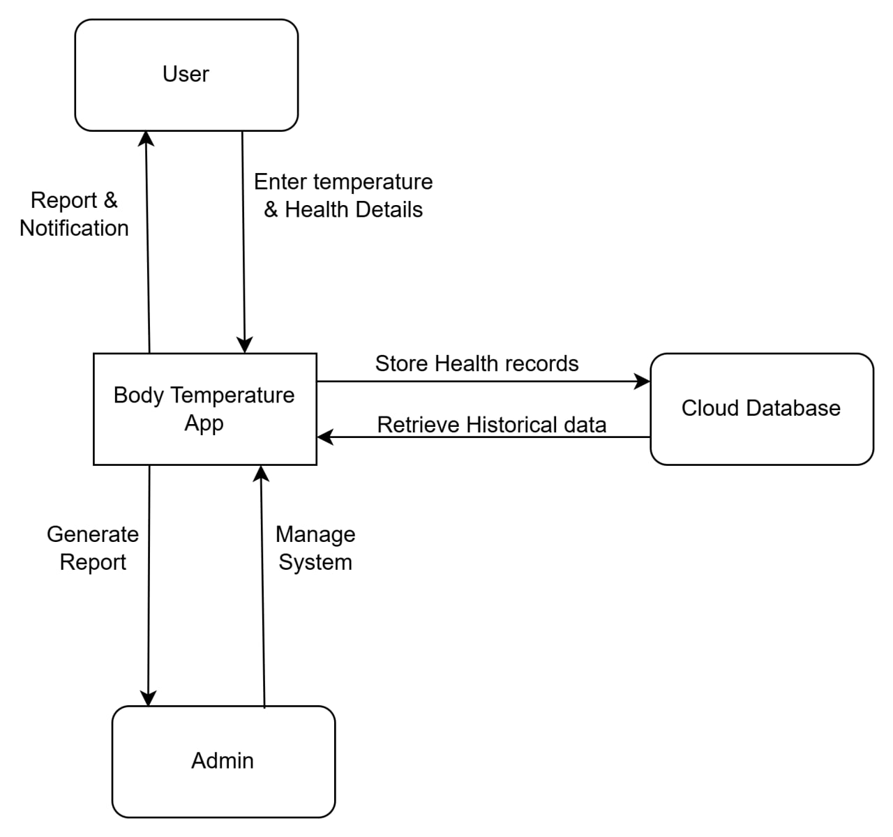

Fig.3.6 Context Diagram

3.7 USE CASE DIAGRAM
The Use Case Diagram of the Body Temperature App shows how users, administrators, and the database interact with the system. Users can register, log in, enter temperature and health details, receive notifications and reports, and view historical health records. The system stores and retrieves health information through the database, while the admin manages the system and generates reports. Overall, the diagram explains how the application collects, processes, stores, and provides health information to support effective temperature monitoring.

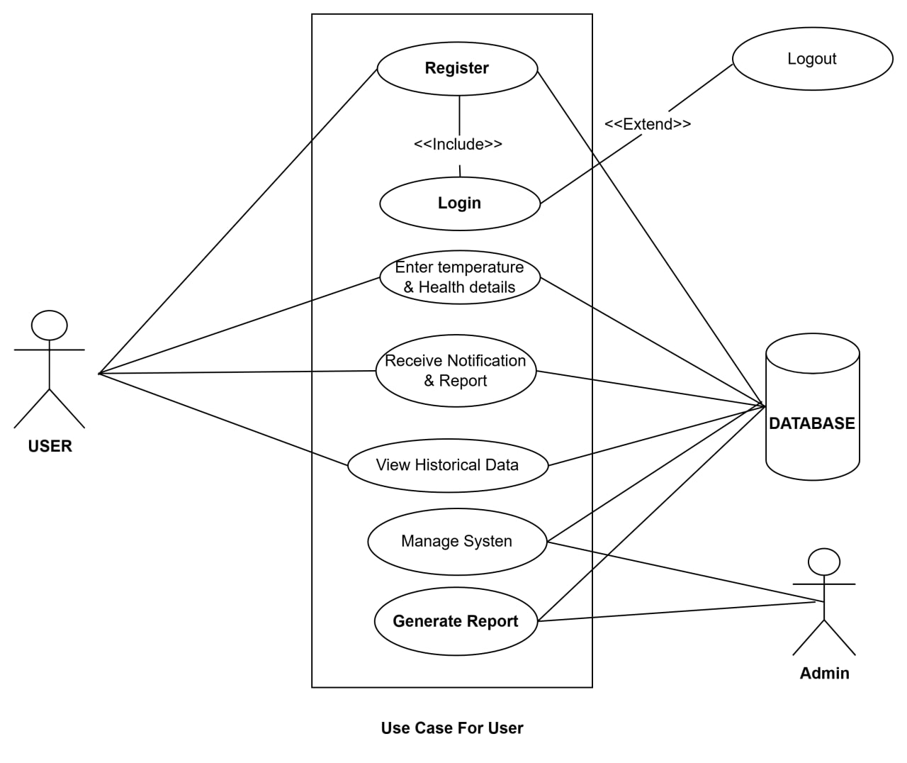

Fig 3.8 Use Case Diagram

3.9 ACTIVITY DIAGRAM
To start, a User enters temperature details, which the System immediately validates. Invalid entries prompt the User to resubmit, while valid data is saved directly into the Database. Next, the System analyses these records and displays the results on the User's screen. The User can then request a report, prompting the System to compile the data and forward it to the admin for review. Once approved, the final report is saved to the Database, successfully terminating the process back in the User's lane.
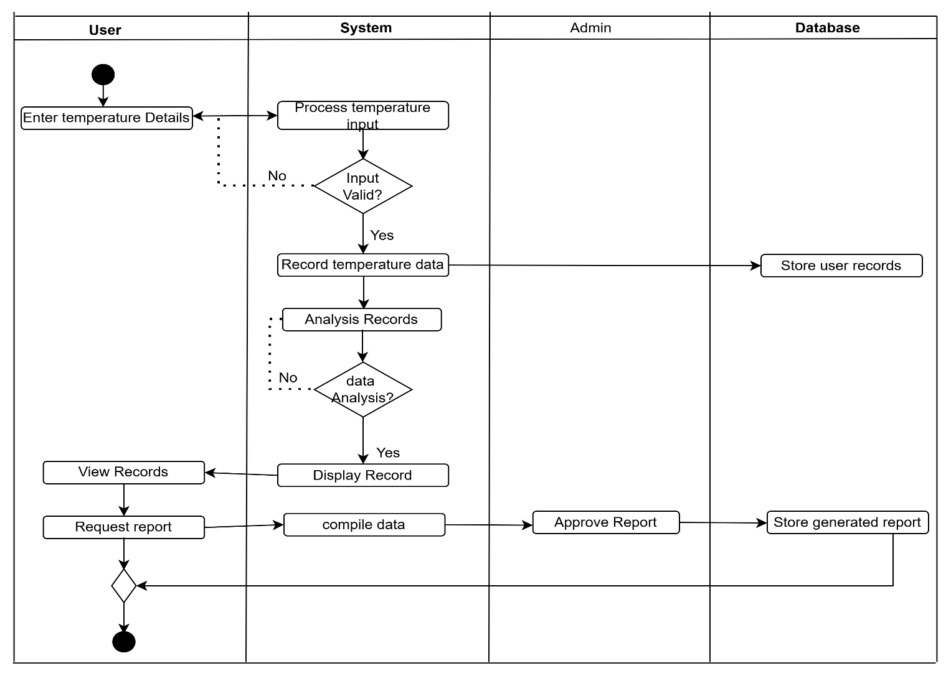

Fig 3.2.1 Activity Diagram

3.2.2 DATAFLOW DIAGRAM
This Data Flow Diagram illustrates how information moves through the central Temperature app process, coordinating data exchange between a USER, an Admin, and the Cloud Database (D1). The workflow starts when the USER submits temperature details, which the system writes directly to the database as a stored health record. When a report is requested, the system pulls historical data from the database, compiles it, and routes it to the Admin for review. Once the Admin sends back an approval, the system saves the finalized document to the database and simultaneously delivers the finished report to the USER.
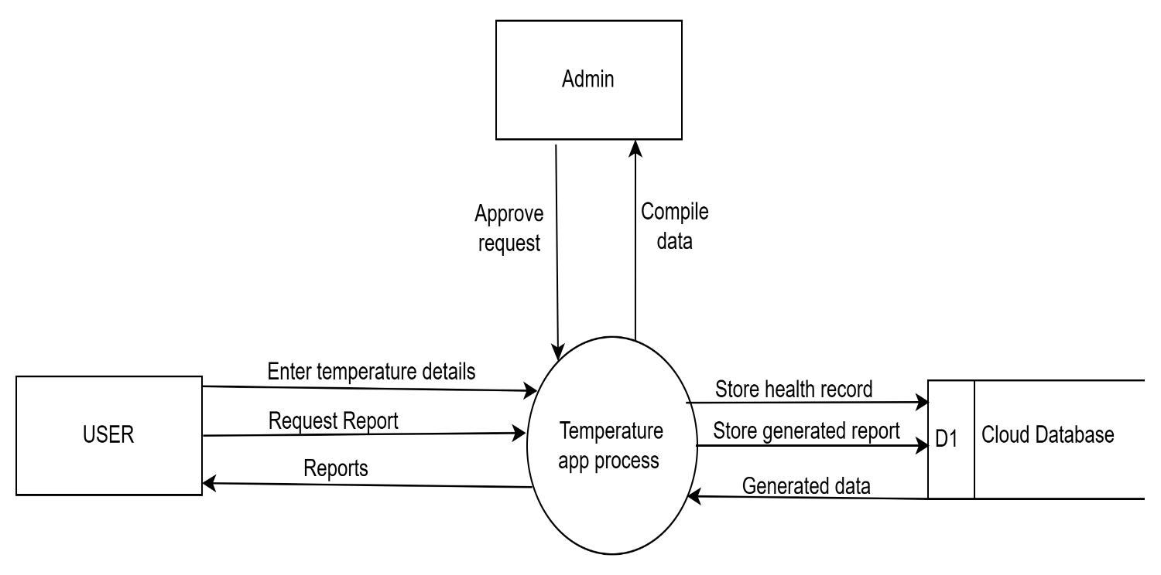

Fig 3.2.3 Dataflow Diagram

2.2.4 CLASS DIAGRAM
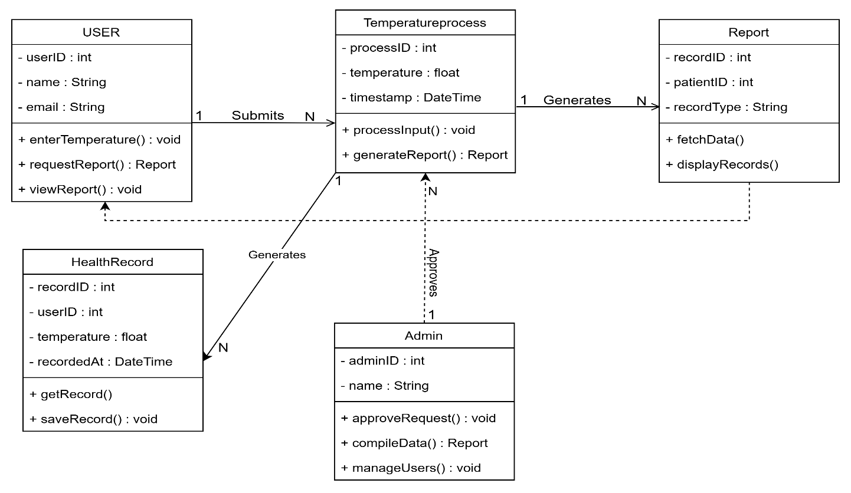
This diagram depicts a simple system architecture for a health or temperature monitoring application. At the top, it shows three key elements: the USER, the Temperature process module, and a Report output. In the middle, a Health Record entity is linked with the label "Generates", indicating that the temperature processing creates or updates health records. An Admin component is positioned at the bottom, suggesting oversight and management of the overall system. The flow implies that users engage with temperature processing to produce records, which then support report generation under administrative control. The diagram uses a minimalistic style with white rectangular boxes on a black background to clearly illustrate these relationships.

Fig 3.2.5 Class Diagram

3.2.6 ENTITY RELATIONSHIP DIAGRAM

3.2.8 STRENGHT AND WEAKNESS OF AN EXISTING SYSTEM
STRENGTHS | WEAKNESSES
Simple and focused on core functionality (temperature tracking, heart rate, breathing rate). | Offline functionality is not clearly mentioned, making the web less useful in areas with poor internet.
Clear client-server architecture with Cloud Database for storing and retrieving historical data. | Heavy dependency on Admin approval for generating reports, which can delay user access.
Supports trend tracking and report generation for sharing with healthcare professionals. | The system appears relatively simple and may not scale well for large number of users or complex health data.
Table 1 strength and weakness

3.2.9 COMPARATIVE STUDY: EXISTING SYSTEMS VS. THE PROPOSED SYSTEM

FEATURES | EXISTING SYSTEM | PROPOSED SYSTEM
Health Parameters Monitored | Temperatures, Heart, Rate, Breathing Rate | Temperature, Blood Pressure, Heart Rate, Blood Oxygen Saturation
Data Input Methods | Manual numeric entry only (not clearly specified) | Structured manual entry, free-text symptom description, or both, with input validation
Architecture | Client-Server with Cloud Database | Client-Server (React Native Mobile + Python Django REST Backend)
Database | Cloud Database | Relational Database (efficient storage, retrieval & management)
Interpretation of Readings | Displays values and trends only; interpretation left to the user | Server-side assessment returning a care recommendation (rest at home, pharmacy, or doctor) with urgency and confidence levels
Handling of Dangerous Readings | No defined escalation path for critical values | Configurable safety thresholds check every submission and force urgent escalation
Scope | General wellness monitoring | Personal health monitoring (not for clinical or hospital use)

Table 2 Comparative study

3.3.1 CONCLUSION
This chapter examined the Body Temperature App as an existing mobile health monitoring system and analysed its major features, system structure, and limitations. The system provides users with a platform to record, monitor, and manage temperature and other wellness information using a client-server architecture. The evaluation of the existing system helped identify areas for improvement, which are addressed in the proposed system through enhanced health monitoring capabilities, improved data management, and a more efficient approach to personal health information management.

CHAPTER FOUR
ANALYSIS OF THE PROPOSED SYSTEM

4.0 INTRODUCTION
The advancement of information and communication technology has improved the delivery of healthcare service through mobile applications. A client-server based mobile personal health monitoring system enables user to monitor their health using mobile devices while securely storing and managing their health information on a centralized server. The proposed system aims to provide an efficient, reliable, and accessible platform for monitoring, storing, and managing users’ health data, thereby supporting better healthcare management and informed decision-making.

4.1 OVERVIEW OF THE SYSTEM
The proposed client-server based mobile personal health monitoring system is designed to help users monitor, store, and manage their health information through a mobile application connected to a centralized server. The mobile application serves as the client, allowing users to record readings and describe their symptoms, while the server handles storage, processing, and security. Each submission is assessed on the server and returned as a recommendation on where to seek care, giving users secure access to their health records and better support for decisions about their health.

4.2 FUNCTIONAL REQUIREMENTS
- The system shall allow users to create an account, log in securely, and access their personal health information.

- The system shall allow users to record, track, and monitor health information such as body temperature, blood pressure, heart rate, and blood oxygen saturation.

- The system shall securely store users’ health records in a centralized database and allow users to view and manage their data.

- The system shall generate health reports based on collected health data to help users understand their health status.

- The system shall provide reminders and alerts for important health updates or abnormal conditions.
- The system shall assess submitted readings and symptom descriptions and return a recommended course of action with an urgency level and confidence rating.

4.3 NON-FUNCTIONAL REQUIREMENTS
- The system shall protect users’ health information through secure authentication and access control to prevent unauthorized access.

- The system shall provide accurate and consistent performance while ensuring users’ health data is stored and available when needed.

- The system shall provide a simple and user-friendly interface that allows users to easily monitor and manage their health information.

  - MAJOR FEATURES/COMPONENTS OF THE PROPOSED SYSTEM
1.User Management
- Handles user registration, authentication, and management of user profiles within the system.

2. Health Data Monitoring
- Allows users to record, monitor, and manage health information such as body temperature, blood pressure, heart rate, and blood oxygen saturation.

3. Mobile Application Module
- Provides an interface for users to access health services, view health records, receive notifications, and interact with the system.

4. Health Report and Notification
- Generates health reports from collected data and provides alerts or reminders based on users’ health information.

5. Server and Database Management
- Stores and manages all system data, including user accounts, health records, monitoring results, and reports while ensuring secure data synchronization.

6. Security and Authentication
- Protects users’ health information through secure login, authentication, and controlled access to sensitive data.
7. Health Assessment and Triage
- Checks each submission against configurable safety thresholds, then assesses the readings and reported symptoms to produce a care recommendation, an urgency level, and a confidence rating.

  - BENEFITS OF THE PROPOSED SYSTEM

- Allows users to continuously monitor and manage their health information conveniently.

- Provides centralized and secure storage of user’s health records.

- Enables users to access and manage their health data anytime and anywhere.

- Help identify abnormal health conditions through monitoring and alerts.
- Provides users with a clear next step after each reading instead of an isolated value.

4.6 CONTEXT DIAGRAM

